**CONTENT MANAGEMENT SYSTEM**

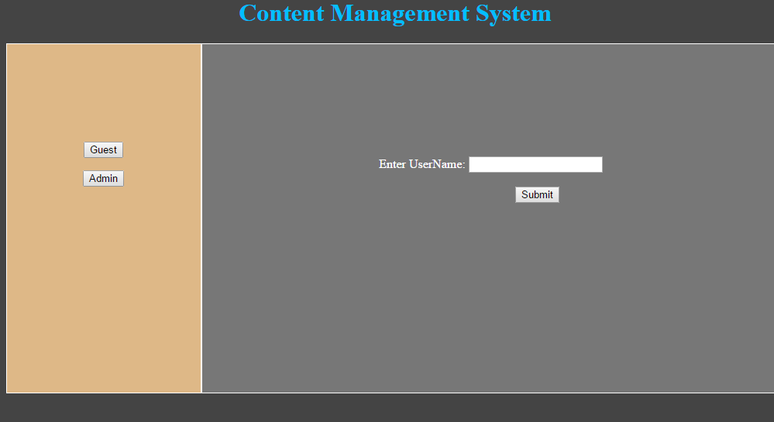

**Admin Login Page**

Username: admin

Password: admin

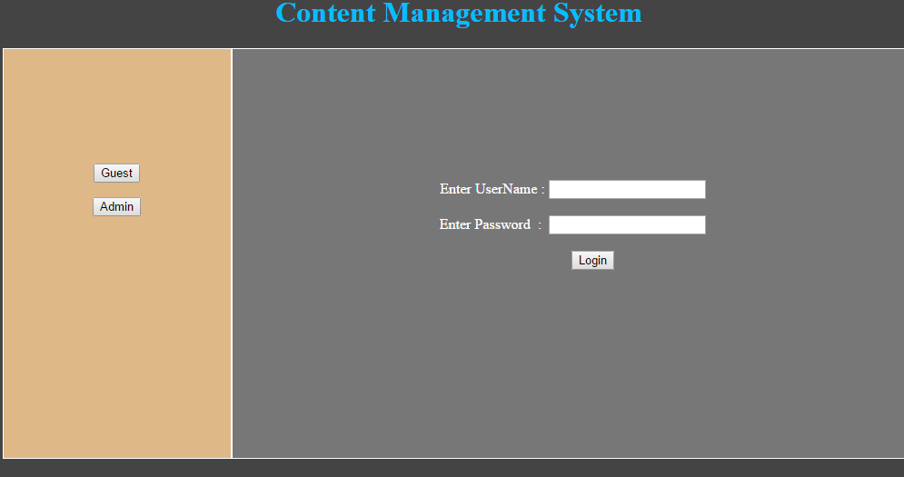

Admin can add blog and give the Title and description (Only Admin)

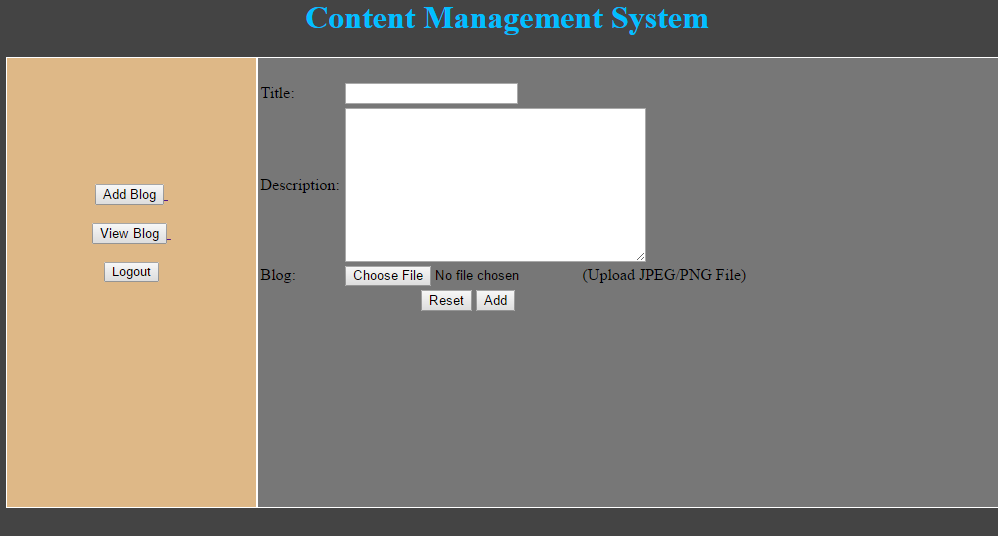

Admin can view the blog and user Comments

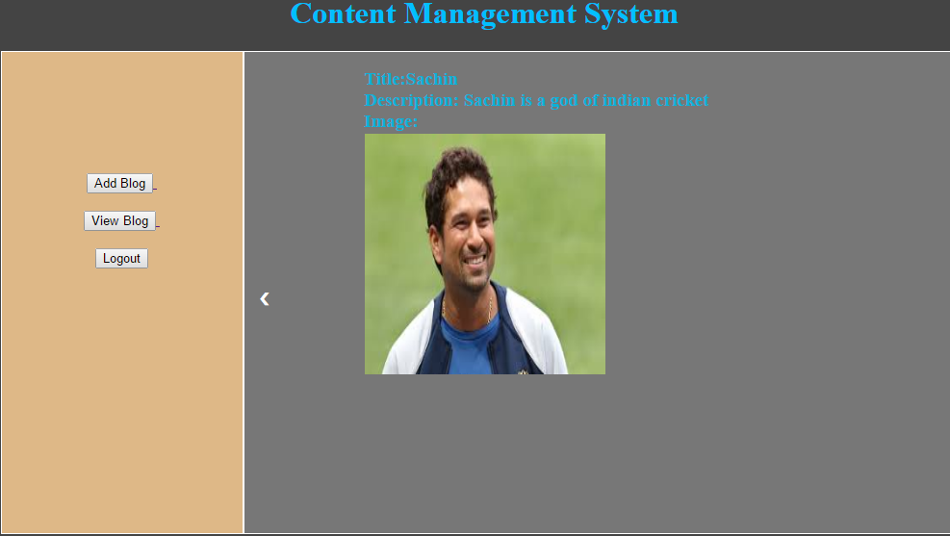

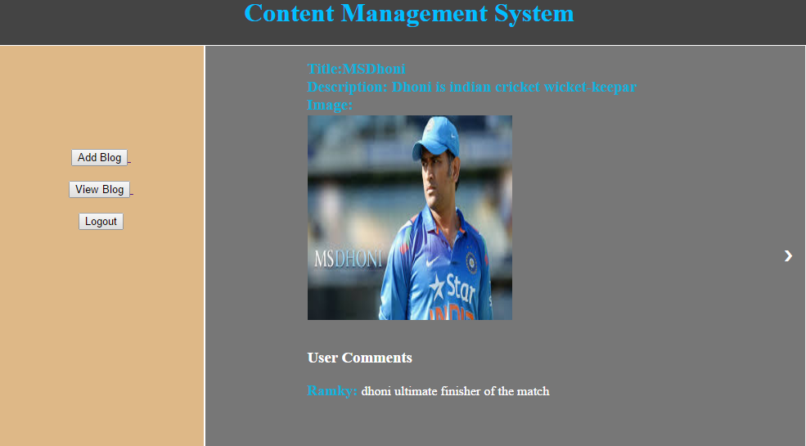

**User Login Page**

Any User (Guest) can be login.

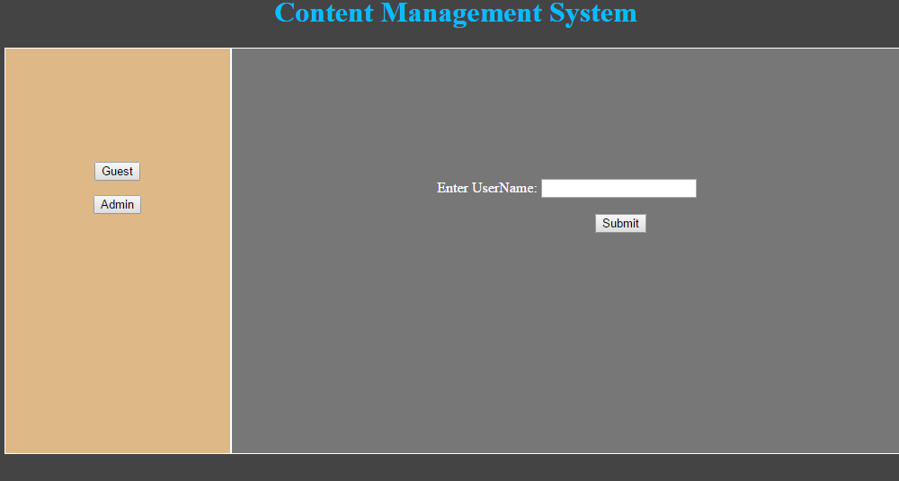

User can be view the blog & user comments and give the comments and twitter about the blog

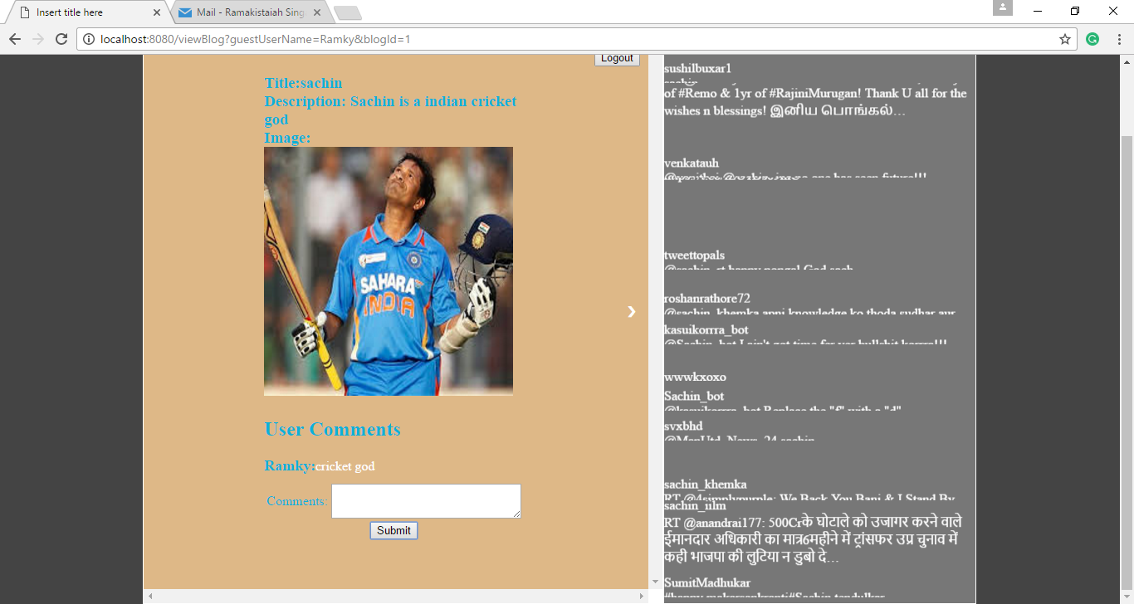

User can be view the next blog and give the comments

